REMOTE HEALTH AND SAFETY SELF-ASSESSMENT CHECKLIST

This is a set of guidelines intended to help you work remotely safely. Do your best to assemble your remote work site according to these guidelines.

Employee Name:
Position Title:
Supervisor Name:

Do you have the following to assist you in your work site?
☐ A space or room where it is easy to concentrate - preferably separate from other living areas and away from a television
☐ Internet connections
☐ Control over temperature, light and sound
☐ Household members who will understand you are working and will not disturb you unnecessarily

Ergonomic Considerations
☐ Is your workstation adjusted properly, so that you can sit comfortably at it?
☐ Do you have good lighting at your remote workstation? For example, you should not have reflections on or glare from the computer monitor.
☐ Do you have a schedule for breaks while working at home? Extended hours in the same body position or repeated motions can lead to various musculoskeletal injuries.
For more information about setting up a workstation, please see refer to the Ergonomic Self Assessment provided below.

Fire Protection
☐ Do you have a properly functioning smoke detector?
☐ Do you have a fire extinguisher and clear access to it?
☐ Are your exits clear?

Emergency Procedures
☐ Do you have first aid supplies?
☐ Do you have emergency contact numbers posted near the telephone?
☐ Do you have a plan for evacuation?
☐ Have you set up a contact schedule with your supervisor?
☐ Does your supervisor know how to reach someone close to you in the event of an emergency?
☐ Do you understand that the regular Hazard and Incident reporting process is the same when working from home?

Electrical Safety
☐ Are any extension cords in good condition and positioned properly?
☐ Are cords and cables organized and secured to avoid causing a tripping hazard?
☐ Are outlets grounded and not overloaded?
☐ Do you have surge protection for electrical equipment?

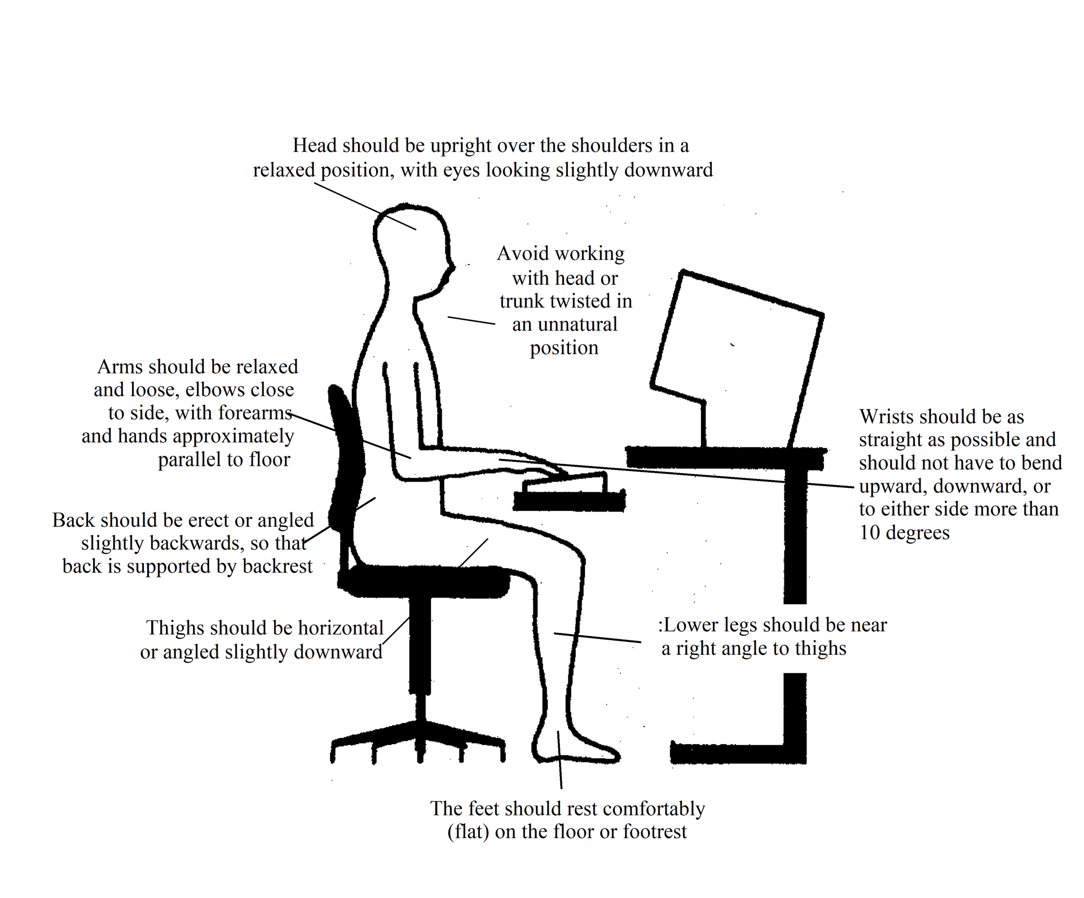
Ergonomic Self
-
Assessment Guide

Keep the following neutral posture guidelines in mind as you work through the checklist.
This quick checklist will assist you to properly set up your workstation when an office move occurs.

Keyboard and Keyboard Tray
- Set angle of platform so that it is flat
- Adjust height so that when typing, the wrists remain in or close to, a neutral position
- If the keyboard tray does not adjust this way, raise or lower chair until wrists/arms are in a neutral position (refer to section on chairs below)
- Set keyboard so that the legs are folded in
- Centre body over alpha portion of keyboard if this is where most of time is spent
- Be aware that it is not necessary to type forcefully

Mouse
- Position mouse so that it is next to the keyboard on keyboard tray
- If there is no room, a mouse house can be used as a temporary measure or the keyboard tray can be extended to accommodate a mouse
- Increase reaction mouse speed to reduce wrist movements

Chair
- Adjust chair so that it offers the best lower back (lumbar) support possible
- Set seat pan to horizontal (neutral) position or angle slightly back for appropriate comfort
- Adjust seat height so that arms and wrists are in a neutral position when typing
- Feet should be flat on floor and knees at approximately 90 degrees – if not, use a footrest

Footrest (if required)
- Place footrest on the floor close to the chair
- Adjust height so that footrest relieves pressure from behind legs when sitting (this can also be accomplished by adjusting the height of the chair)

Wrist Rest
- Be aware that when typing, wrists should not rest on a sharp edge such as desk edge
- Use a wrist rest only when not typing
- Be aware that a wrist rest is designed to help keep wrists straight

Monitor
- Locate monitor directly in front of keyboard
- Top of monitor display screen should be at eye level when sitting up straight (may need to be slightly lower for bifocal and trifocal users)
- Be aware that bifocal or progressive lens wearers may experience difficulty, and may want to change to eyewear better suited for the work environment (consult with optometrist or ophthalmologist)
- Keep monitor far enough away so that it can be read comfortably (for most people this will be about an arm’s length away)
- Adjust the contrast and brightness to a comfortable level (generally high contrast and low brightness is best)

Desk
- Organize accessories on desk so that items used most frequently are close by, e.g.:
− Frequently used 0 - 30 cm (0 - 12 inches)
− Occasionally used 30 - 50 cm (12 - 20 inches)
− Seldom used more than 50 cm (more than 20 inches)
- Manage keyboard and mouse wires by routing them underneath the desk so they are not in the way
- Place telephone on left side if right handed and vice versa
- Be aware a telephone headset is a good alternative if phone is used frequently or for prolonged periods
- Use a telephone stand if numbers on the telephone screen are difficult to read

Lighting
- Adjust the level of light (if possible) to make it easy to see the screen without squinting or straining
- Adjust the computer screen by tilting or moving so it is free of reflected glare (a monitor visor and/or an anti-glare screen can be utilized)
- Position monitor so that line of sight is parallel to window (if possible)
- Ensure there is enough light to read documents easily

Desk Lamp (Task Lighting)
- Move desk lamp so that it illuminates the documents being worked on
- Avoid having the light directed at monitor, face or eyes
- Ensure task lighting is a type where bulb is sufficiently recessed so as not to cause a bright spot in field of vision

